Theory Answers

IoT Summer School 2026 Author: SATYAM KUMAR

This file contains the written theory answers for the module 2

Module 2 – IoT Fundamentals

Q11. 4-Layer IoT Architecture
The IoT architecture has four main layers:
Perception Layer – This is the bottom layer with the sensors and actuators that collect data from the real world or act on it. Example: DHT11 temperature sensor, LED.
Network Layer – This layer sends the collected data from the devices to the processing part. Example: WiFi (ESP32), Bluetooth, MQTT.
Processing Layer – This layer processes and stores the data, often on a server or in the cloud. Example: cloud server, MQTT broker.
Application Layer – This is the top layer where the user actually sees and uses the data. Example: a mobile app or a web dashboard.
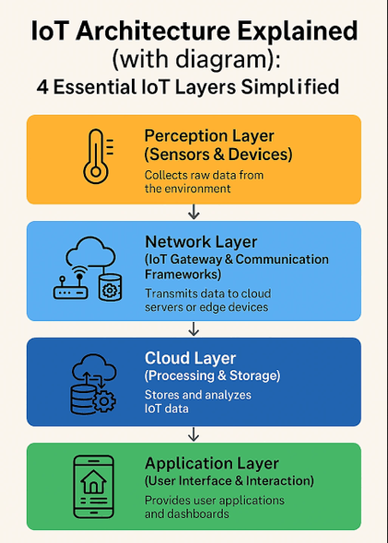

Q12. Microcontroller vs Microprocessor
Parameter | Microcontroller (Arduino UNO) | Microprocessor (Raspberry Pi)
CPU Speed | 16 MHz | around 1.5 GHz
On-chip RAM | 2 KB | 1 to 8 GB
On-chip Flash | 32 KB | uses an SD card (GBs)
Operating System | None, runs one program | Full OS (Linux)
Typical Use Case | Simple control and sensors | Full computing tasks
Power Consumption | Very low | Higher
In short, a microcontroller like the Arduino UNO is small and made for simple control tasks, while a microprocessor like the Raspberry Pi is much more powerful and runs a full operating system.

Q13. Arduino Pin Types
Digital Input – Reads a value that is either HIGH or LOW (on or off). Example: reading a push button. IoT use: a door open/closed sensor.
Digital Output – Sends out a HIGH or LOW signal. Example: turning an LED on and off. IoT use: switching a relay to control an appliance.
Analog Input – Reads a range of values from 0 to 1023. Example: reading an LDR or a potentiometer. IoT use: monitoring the light level outside.
PWM Output – Uses the ~ pins to fake an analog output from 0 to 255. Example: changing LED brightness or motor speed. IoT use: dimming a street light to save power.
I2C / SPI pins – Used to communicate with other chips and sensors. On the UNO, I2C uses A4 (SDA) and A5 (SCL). IoT use: connecting an I2C LCD display or a sensor.

Q19. analogWrite() vs analogRead() and PWM
analogWrite() sends out a signal using PWM, so a pin can act like it has values between fully on and fully off (0 to 255). It is used to control things like LED brightness or motor speed.
analogRead() does the opposite. It reads an analog voltage coming into a pin and gives a value from 0 to 1023. It is used to read sensors like an LDR or a potentiometer.
PWM (Pulse Width Modulation) works by switching a pin on and off very fast. By changing how long it stays on in each cycle, the average power changes, so an LED looks dimmer or brighter. It is used because a digital pin can only be fully on or off, and PWM lets it act like it has in-between values.
Example from my work: I used analogWrite in my PWM night light to fade an LED, and analogRead in my street light to read the LDR value.

Q20. setup() and loop(), and the effect of delay()
setup() runs only once when the board turns on. It is used for one-time preparation like setting pinMode or starting Serial.
loop() runs over and over again forever after setup. It holds the main repeating logic of the program.
If you put a long delay() inside loop(), the whole program freezes during that delay and cannot do anything else, like reading a sensor or a button. This makes the device slow to respond, and a button press could be missed while it is waiting.
The non-blocking alternative is to use millis(), which checks how much time has passed without freezing the program. This way the device can keep reading sensors while still timing things. I used this idea in my reaction game and traffic light.

